**IST772 Week 2 Breakout – Binomial Distribution**

Instructions: For 1-5 below, paste the R code and results under each.

Pascal’s Triangle was named after 17th century French mathematician Blaise Pascal, but the structure appears to have emerged independently from India, China, and Persia as early as the second century BC. Each entry is the number of different ways of choosing k elements from a set with n elements. Think of n as the row number (starting with 0) *and* the number of coins we are tossing. Then k is the position within a row (starting with zero) and is also the number of heads. The third row below would read like this: Tossing two coins, there’s one way to get zero heads, two ways to get one head, and one way to get two heads.

1

1 1

1 2 1

1. **Create a Pascal’s Triangle** with this R code: lapply(0:7, function(i) choose(i, 0:i))

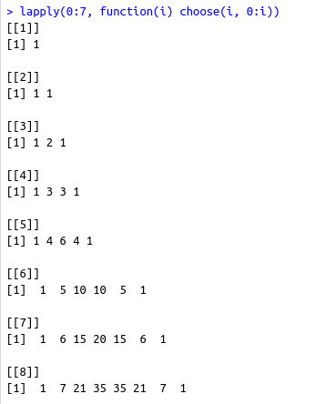

1. If all is well, the sum of the entries on your final row should be 128 (by the way, that is also 2 raised to the seventh power). **Check this with the sum command**: sum(choose(7, 0:7))

**Now convert the lowest layer of your triangle to probabilities** using this R command:

choose(7, 0:7)/128





1. **Use rbinom() to create a list of ten trials**, where each trial consists of seven events (e.g., coin tosses). Set prob=0.50 to use a fair coin.



1. **Modify your rbinom() code to run 100,000 trials of a coin toss with seven events. Create a table showing the number of events for each of the eight outcomes.** (Hint: in addition to rbinom() you will need the table() command.) Divide the output of the table command by 100,000 to display the proportion of trials in each category.

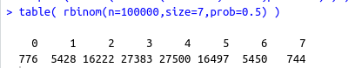

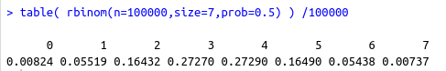

1. **Use the following line of code to produce the probabilities for a binomial distribution with seven events**: dbinom(x=0:7, size=7, prob=0.5)

